Evolve Ad Formats

Video Formats:
Voiceover with b-roll:
- Voice-over footage/product shots (Real or AI)
- Usually has low-volume background music that flows with the ad
- Heavily edited with multiple clips (UGC,A-Roll,stock)
Example:
https://f.io/V_b1Th2b
Subtitles with b-roll:
- Generated subtitles over footage/product shots (Taps into internal voice)
- Usually, has background music flows with the ad
- Music selection very important
- Heavily edited with multiple clips
Example:
https://f.io/PfaqXBS7
Slideshow Video w Text:
- Static images with transitions
- Heavy text overlay with movement
- Text reveals
- Can add a voice over if your want
Example (has video clips, but mainly referring to the “Images”):
https://f.io/dGxDSUWH
Authentic UGC/Talking head only
- Person speaking directly to camera (can be real or AI - use ai ay your own risk)
- Casual, authentic feel
- Usually single-take or minimal editing

Example:
https://www.instagram.com/p/DBs1mjjApc3/

Professional shot video:
CR8TIVE - Nurojit Video 1.mov
- High production value
- Professional lighting/equipment
- Polished, branded look
- Not recommended dosen’t covert super well right now

Animation:
- Animated characters/graphics
- Can be 2D, 3D, or motion graphics
- No real people/locations
Examples:
https://f.io/tRROIcOJ

Image Formats:
Static graphic/design:
- Colorfully designed graphics with text overlays (like Canva templates)
- Has a visual of the product in it (can be without, but more for advanced marketers)
- Think Bold headlines on branded backgrounds
Example:
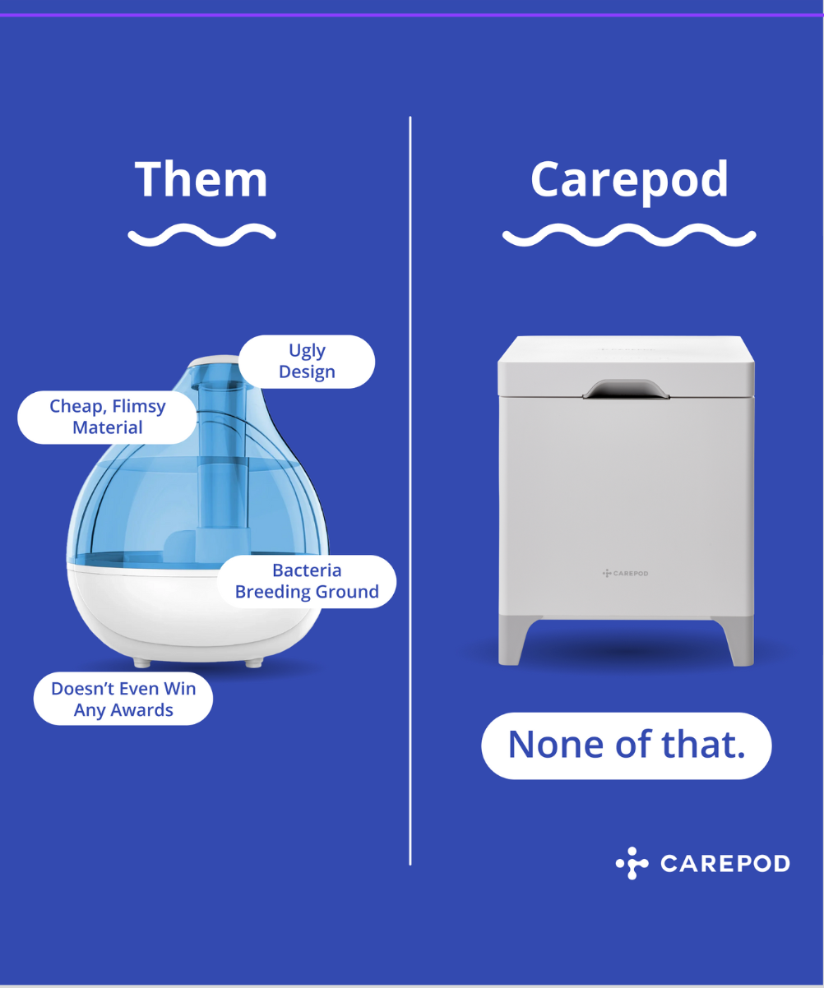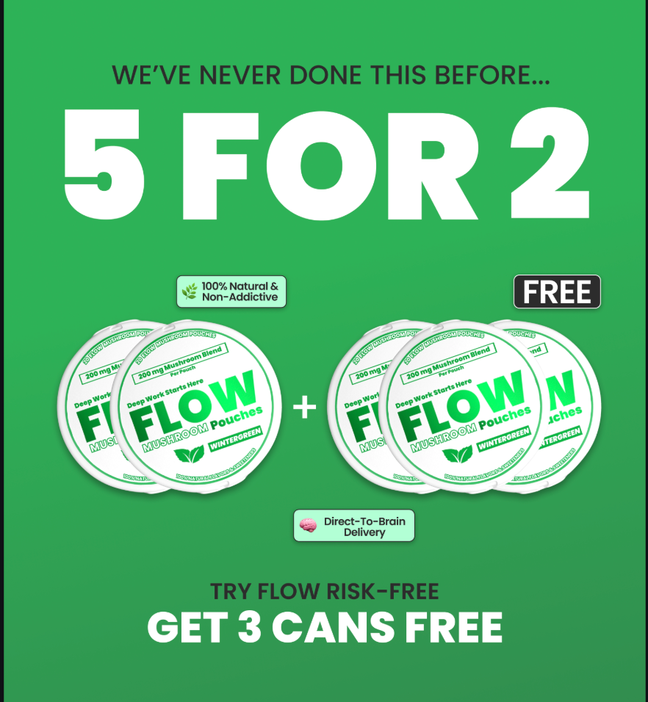

Product photography + Headline
- Clean, professional photos of the product
- Can be on white/neutral backgrounds
- Can be lifestyle shots as well
Example:
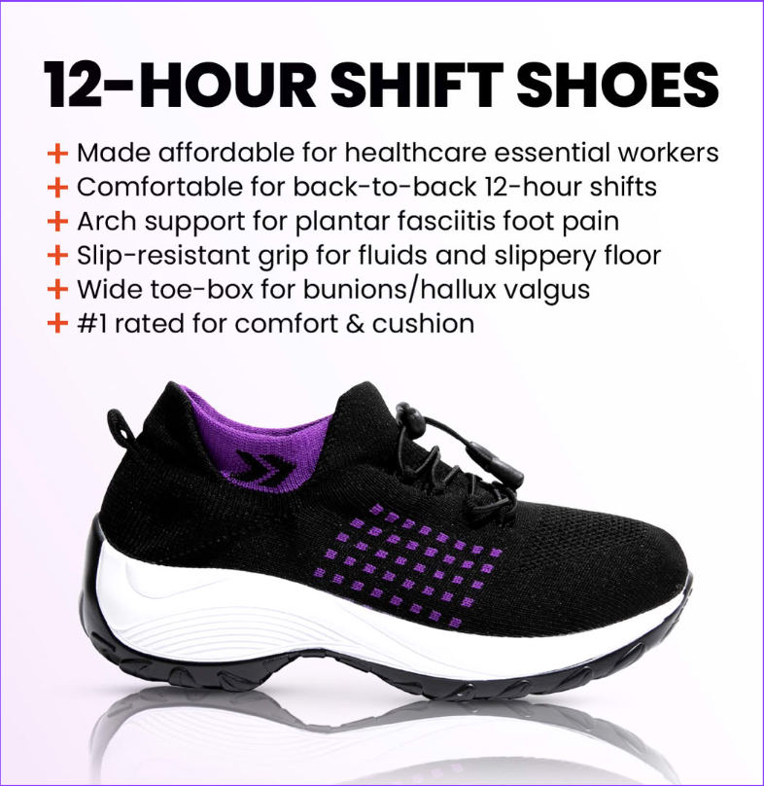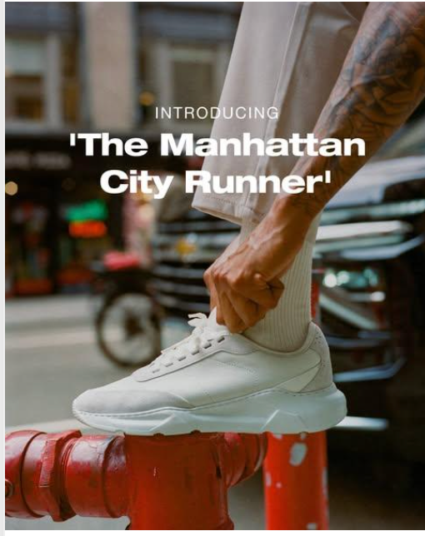

Infographic designs:
- Visual charts, graphs, or step-by-step processes
- Combines data/info with visual design
- Example: "3 Steps to Better Sleep" with icons and text
Example:
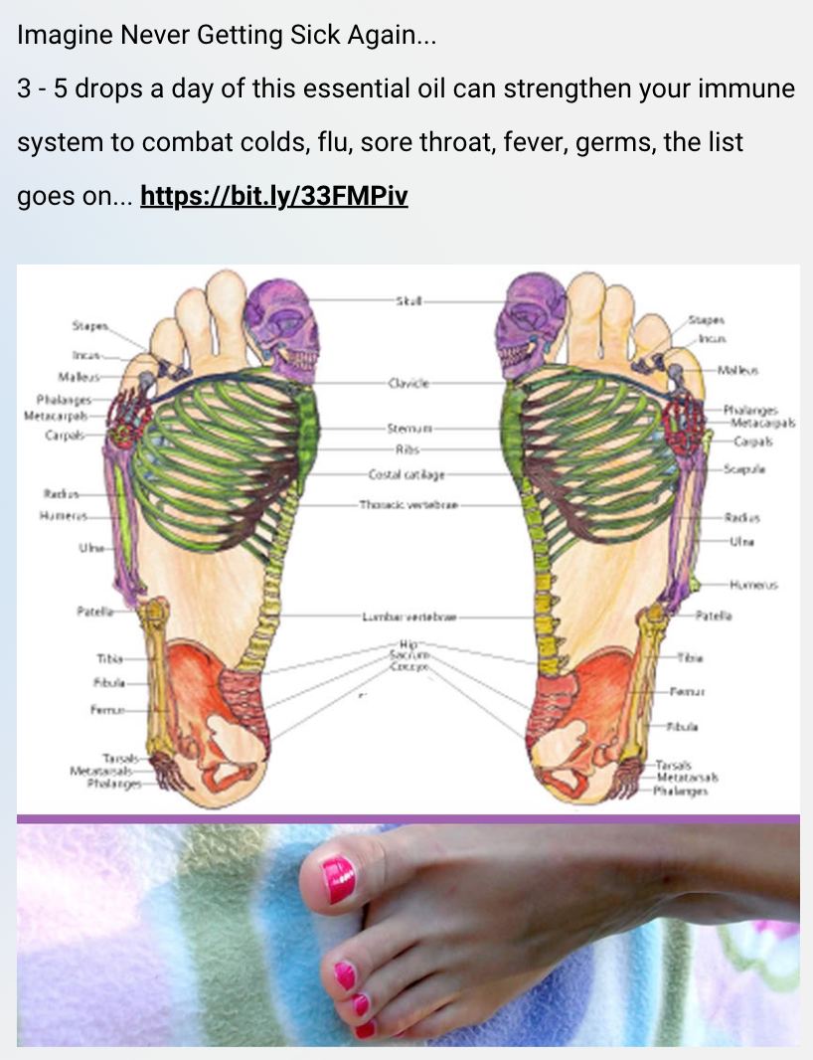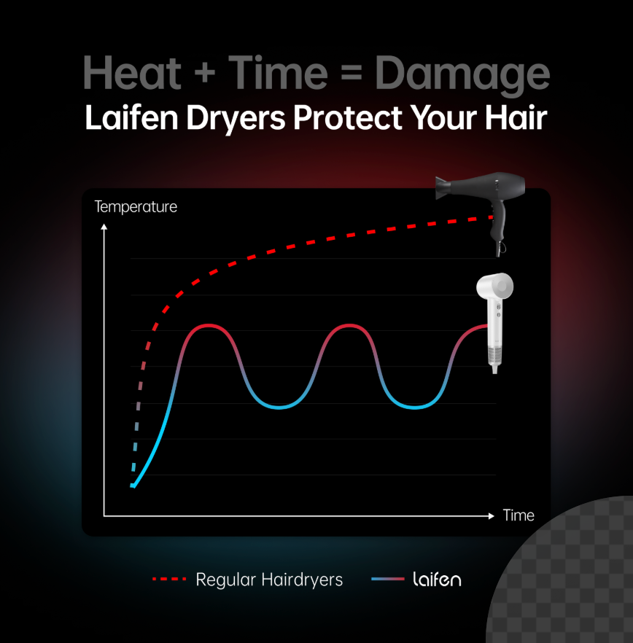

Native-style image:
- Designed to look like it’s native to the platform (organic)
- Mimics organic social media posts (like Pubity style)
- Often looks "unbranded" or casual
- 🚨IMPORTANT → DO NOT FAKE PRESS RELEASE ADS (This is false advertising)
Example:
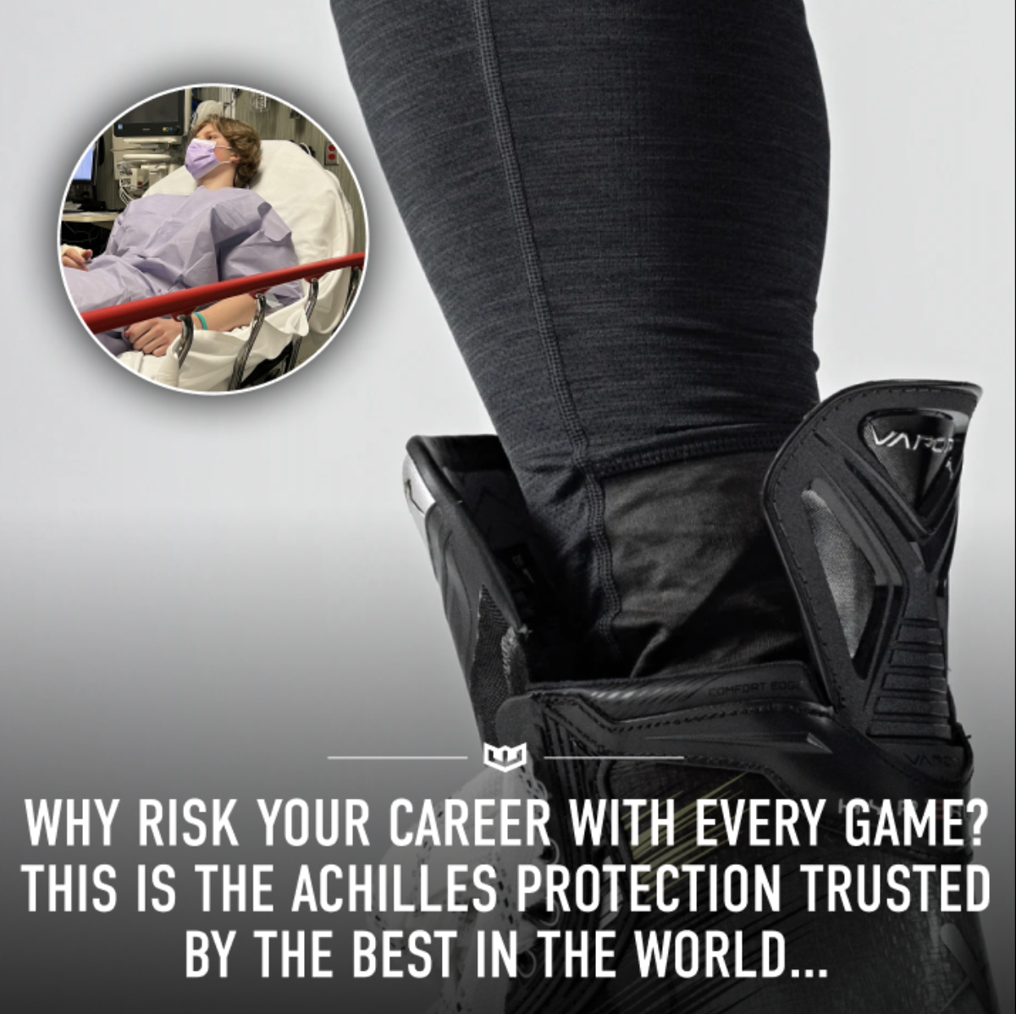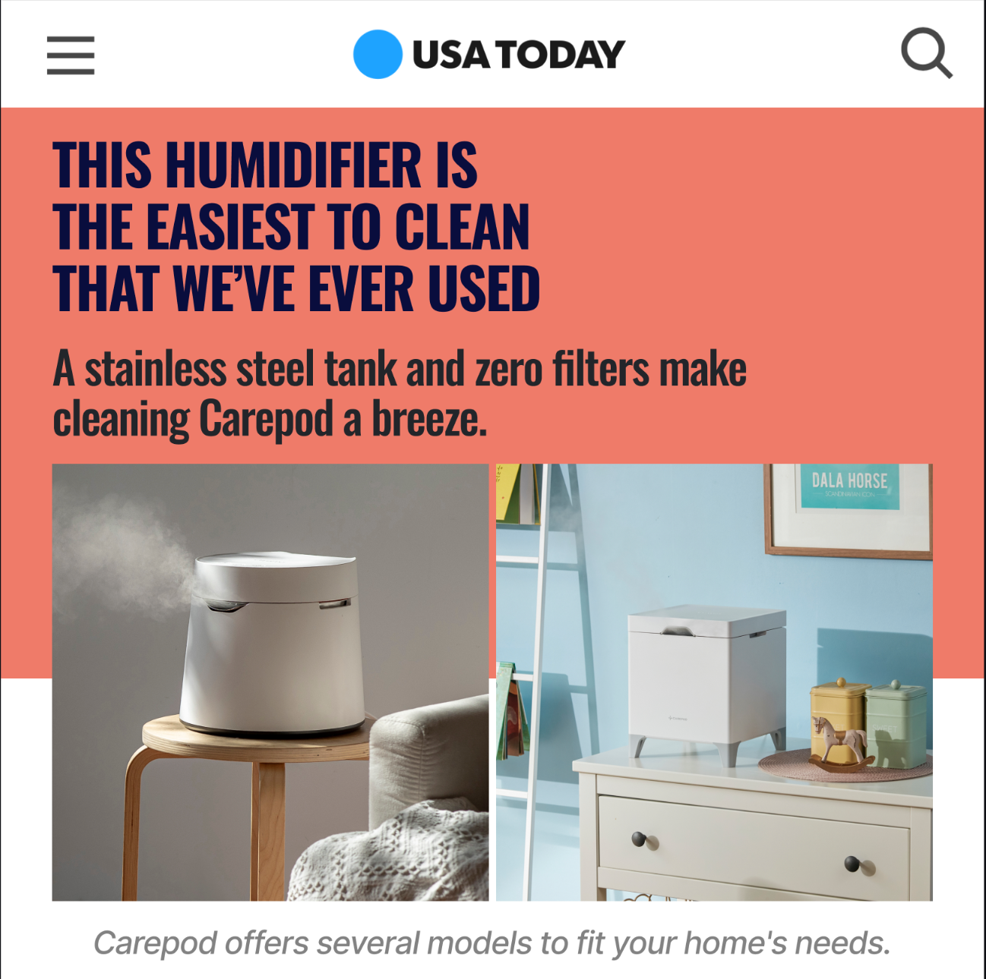
Quote/Text-heavy image:
- Mostly text with minimal design
- Quote-style layouts
- Text is the main focus, not visuals
Example:
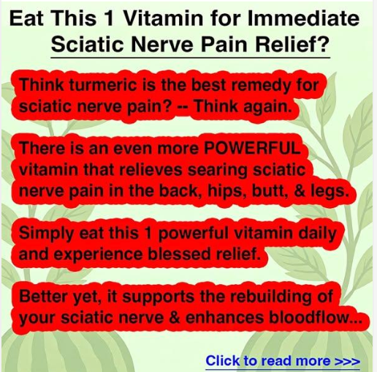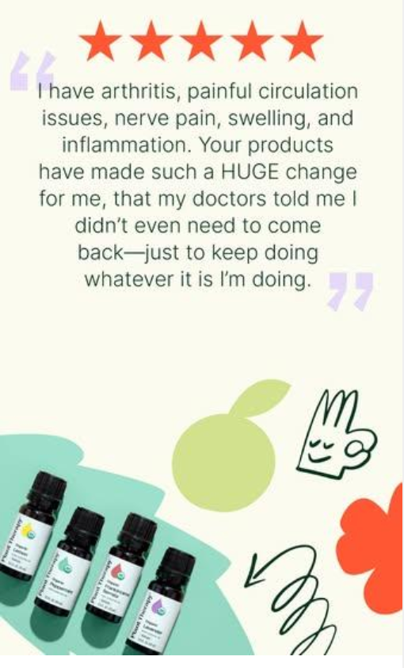

Collage style:
- Multiple images combined
- Grid layouts or scattered arrangement
- Shows multiple angles/uses
Example:
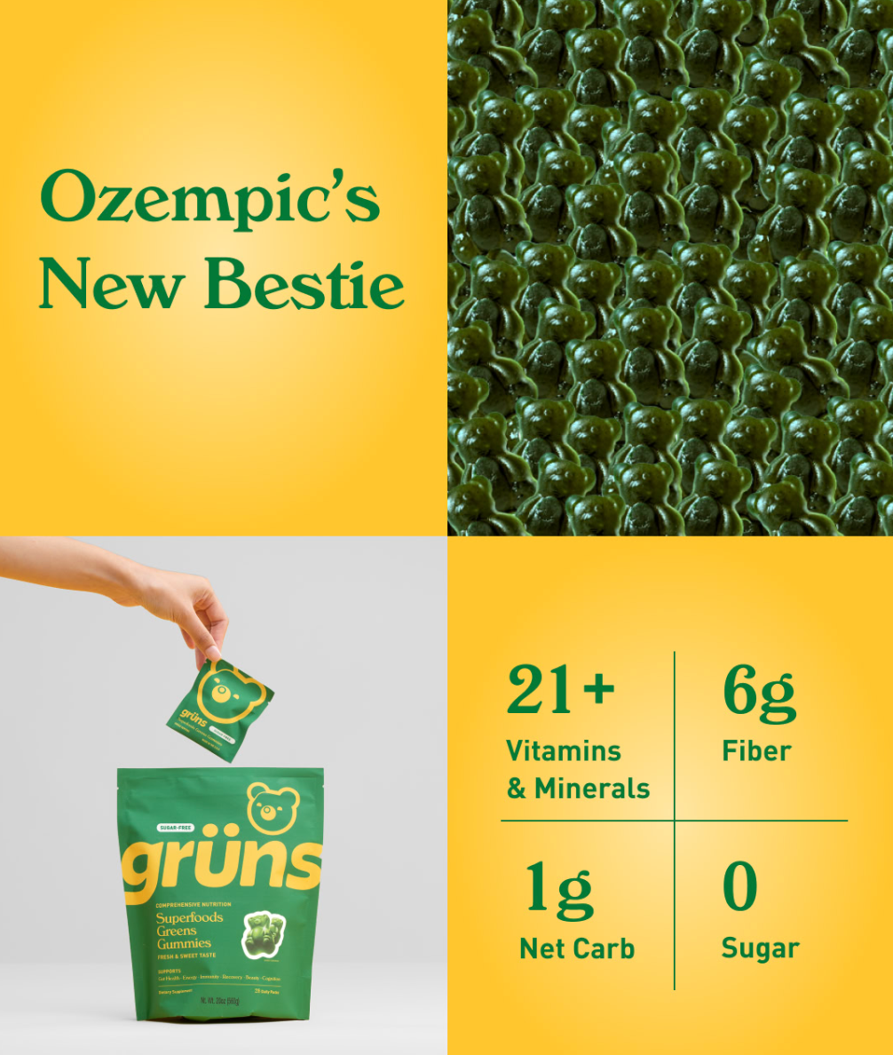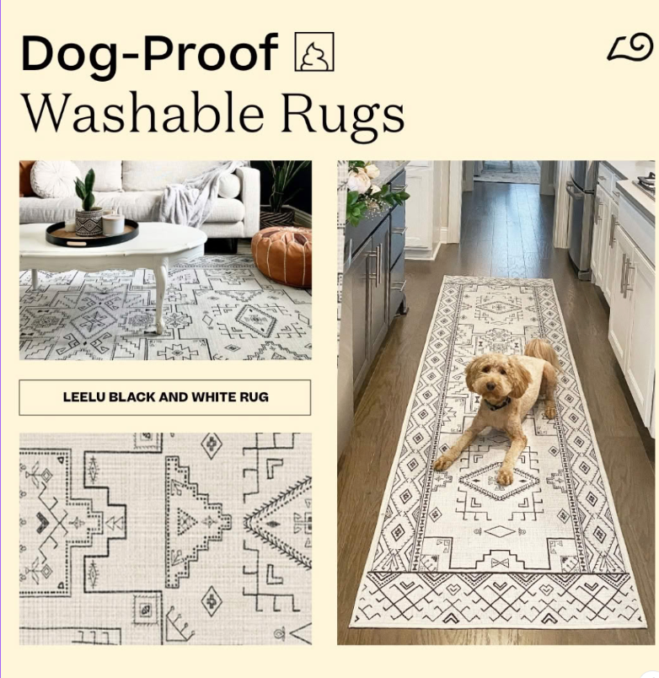
User-generated content (UGC) image:
- Actual customer photos/selfies
- Real people using your product
- Authentic, unpolished look
Example:
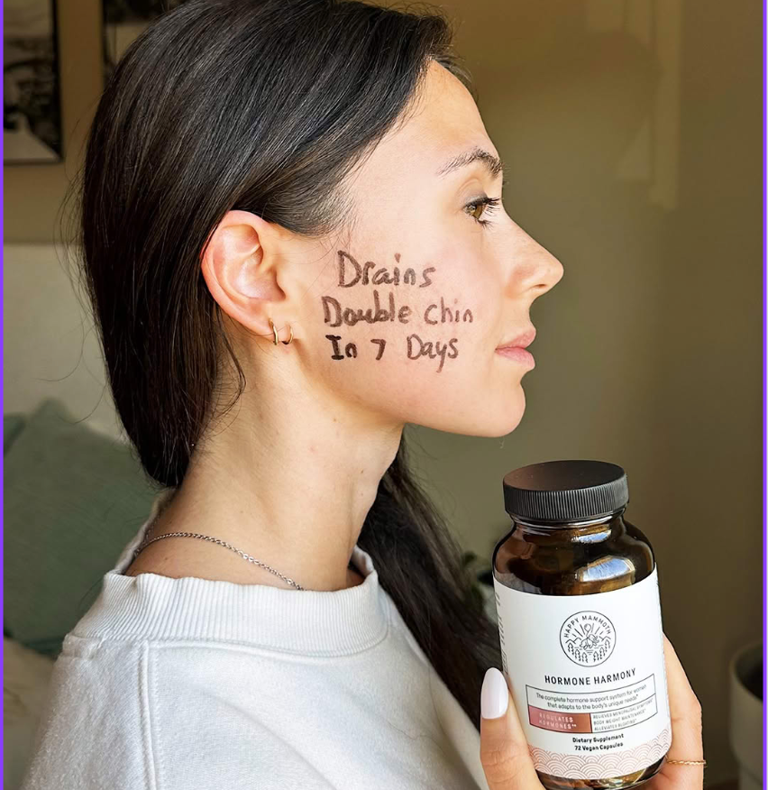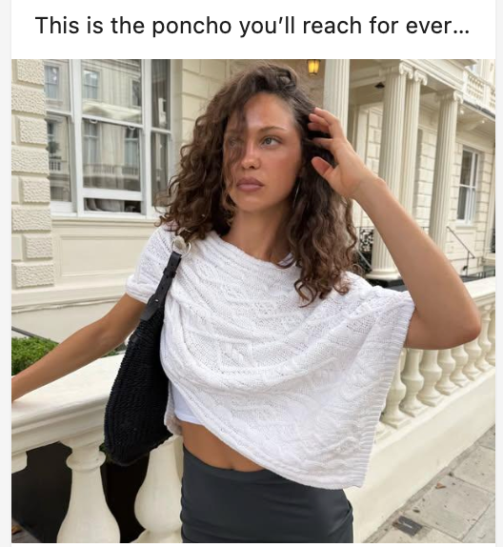

Meme-style image:
- Popular meme templates with custom text
- Often uses recognizable meme formats
- Example: Drake pointing meme with your product comparison
Extra Sauce:
https://imgflip.com/memegenerator
Example:
